**20a Derrymore Road**

**Gawley’s Gate**

**Craigavon**

**BT670BW**

**Phone: 028 92651556**

email: [cmcatarsney425@c2kni.net](mailto:cmcatarsney425@c2kni.net)



**April Bulletin 2024**

Dear Parents

I would like to welcome everyone back for our final term of the year. Please take a few moments to read this month’s bulletin. I would particularly like to draw your attention to the first two items on the bulletin: Online Safety Workshop and Being Well, Doing Well.

**HIGH IMPORTANCE: INTERNET SAFETY WORKSHOP FOR PARENTS**

**Tuesday 23rd April 8pm: School Assembly Hall**

In recent years, problems and difficulties experienced by some of our pupils begin online! As a parent or carer, it can be difficult to navigate all the new platforms and games, let alone talk to your child about online safety.  Whether they’re gaming, chatting, posting, or streaming, we want to support parents to help keep children safe online.  When it comes down to it, parental monitoring isn't about privacy, it's about safety.

Not only are children spending more time on the web, but the lines between their online and offline lives are becoming increasingly blurred.

Time spent online can be positive. It offers endless opportunities for young people to make friends, have fun and learn new things — they can learn, play and connect with peers. However, it can also pose real-life dangers — from online bullying and threats to sexual abuse and poor mental health.

We would encourage as many parents as possible to attend this Internet Safety workshop. It is open to parents of all pupils from P1 to P7.

***PLEASE REPLY USING THE ONLINE FORM PREVIOUSLY SENT TO YOU IF YOU WOULD LIKE TO ATTEND.***

**HIGH IMPORTANCE: BEING WELL DOING WELL**

Our school is part of an exciting pilot project organised by EANI. The aim of the Being Well, Doing Well programme is to assist schools to develop a whole school approach and framework to Emotional Health and Wellbeing. (EHW)

As a participating school, we will receive support to assess current practice and identify further steps to develop EHW within our school. Staff will also be provided with opportunities for professional development which will equip them with further knowledge, skills and confidence to understand, promote and implement the EHW ethos in the school.

* **As we begin this journey, we would ask parents and carers to complete an online questionnaire as part of our baseline audit.**
* **This process will help us identify strengths and gaps for improvement.**
* **You will need to use the QR code or link below to access the online questionnaire.**
* **The responses are all anonymous.**
* **Please complete by Friday 19th April.**

<https://forms.office.com/e/cS3RrU2hB5>

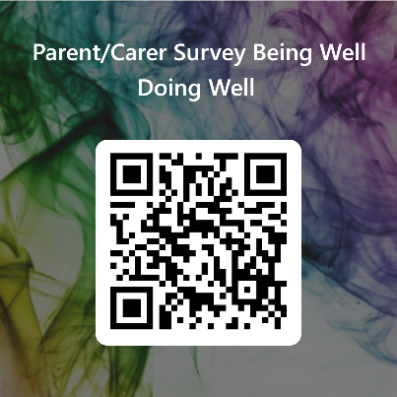

**STANDARDISED TESTING**

Every year, we carry out standardised testing with pupils from P3 to P7 in English and Maths. The testing will take place this year between 7th May and 17th May.

**FIRST COMMUNION**

Our P4 children will make their First Holy Communion on Friday 24th May at 12am in St Patrick’s Church, Aghagallon. Further information for P4 parents and details about the ceremony will follow from Mr MacDonald closer to the date. The P4s will attend Mass and rehearsals on Monday 13th May and on another date to be confirmed.

* **School will operate as normal for other pupils on this day.**
* **Choir members will be transported to and from the church on this day.**

**GAELIC TRAINING**

Gaelic training for P5, P6 and P7 will continue every Thursday from 3 – 4 until further notice. A number of blitzes have been organised. Those involved will be informed prior to each blitz. I would like to thank Mr Fegan and Kieran who give freely of their time and talent to coach and inspire our children.

**CYCLING PROFICIENCY**

We are delighted to be able to offer the cycling proficiency course to our P6 and P7 pupils. Thank you to Mr Fegan and Mr MacDonald for facilitating this after school activity.

**BEE ACTIVE**

Our Bee Active sessions will continue each Friday with our amazing and inspirational coach, Anto.

**MAY PROCESSION**

A few years ago, we started a new tradition in our school during the month of May. As our school is called St Mary’s, it is only fitting that we honour Mary in some way. We plan to hold our annual procession on Wednesday 8th May at 1.15pm in the school grounds. ***Parents and family members are invited to attend.***

**DINNER MONEY**

Could we ask that all dinners are paid for in the week they are taken. Dinners must be paid for using the school money app. School dinners cost £2.60 per meal. Please ensure that all payments are kept up to date.

**FINALLY**

Please see key dates for term 3 below. Some of these may be subject to change and further dates are still to be added for school trips.

I continue to be grateful to all our parents and families for the support, commitment and dedication you show to your children and to our school.

Mrs Caitriona McAtarsney

Principal

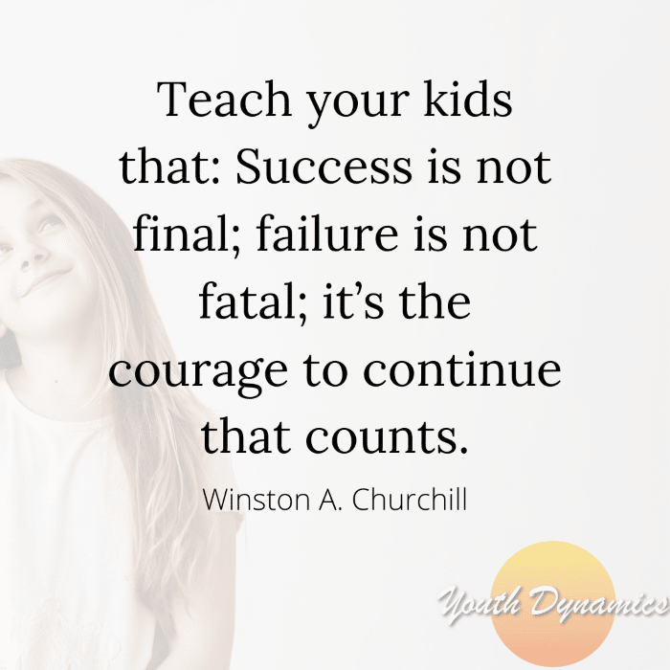 

|  |  |
| --- | --- |
| **TERM 3 DATES** | |
| **Week 1** | |
| Monday 8th April | Staff Training Day |
| Wednesday 10th April | Cycling Proficiency P6 and P7 |
|  | |
| **Week 2** | |
| Tuesday 16th April | P4 Retreat Day |
| Wednesday 17th April | P6 Emotional Intelligence Workshop (Motus Learning) |
| **Friday 19th April** | **Please have Being Well, Doing Well questionnaire completed** |
|  | |
| **Week 3** | |
| Tuesday 23rd April | P6 Art Project in school (Facilitated by St Ronan’s College) |
| **Tuesday 23rd April** | **Internet Safety: Parent Workshop 8pm in School** |
| Wednesday 24th April | Being Well Doing Well (Visit by link Officer) |
| Thursday 25th April | Letters issued to P1 applicants for Sept 24  Gaelic Blitz |
|  | |
| **Week 4** | |
| Monday 29th April | Library Van Visit P4 – P7 |
|  | |
| **Week 5** | |
| Monday 6th May | School Closed |
| Wednesday 8th May | May Procession:  Parents and family members are welcome to attend. |
| Thursday 9th May | Gaelic Blitz |
|  | |
| **Week 6** |  |
| Monday 13th May | P4 Communion Rehearsal |
| Wednesday 15th May | P7 Love for Life Programme |
| Saturday 18th May | P7 Post Primary Admissions: letters issued to P7 pupils |
|  | |
| **Week 7** |  |
| Thursday 23rd May | Gaelic Blitz and P4 Communion Rehearsal |
| Friday 24th May | P4 First Communion 12 o clock |
|  | |
| **Week 8** |  |
| Monday 27th May | Holiday: School Closed |
| Tuesday 28th May | Holiday: School Closed |
| Friday 31st May | Sports Day |
|  | |
| **Week 9** |  |
| Monday 3rd June | P1 and P6 Attending Mass in Aghagallon |
| Tuesday 4th June | P6 Taster Day in St Ronan’s College |
| Thursday 6th June | P7s going to St Ronan’s College will go there for CAT4 test |
|  | |
| **Week 10** |  |
| Monday 10th June | P7 Leavers Mass 10am ST Patrick’s Church Aghagallon |
| Wednesday 12th June | P1 Induction Day 1.15pm (P1 will finish at 12) |
| Sunday 16th June | Voices of Hope Concert (Details to be confirmed) |
|  | |
| **Week 11** |  |
| Thursday 20th June | Leavers Concert and Awards 1.15pm |
|  | |
| **Week 12** | |
| Monday 24th June | Final Library Van Visit P4 – P7 |
| Friday 28th June | School closes at 11.30 |